**BA/DA TRAINING**

**Assignment – 3(July 9,2019)**

**SHAFALI GUPTA**

1. **DOD-**  Definition of done means coded based on the company coding standard, reviewed, implemented, test driven development, tested with test automation, integrated with other interfaces and documented.

Done means every task under the user stories has been completed and any work created is attached to the user story so the product owner can review it and make sure it meets his/her expectations

1. Created the account for **Agile Accelerator** and explored some options.
2. **Screenshot for Sprint 1**

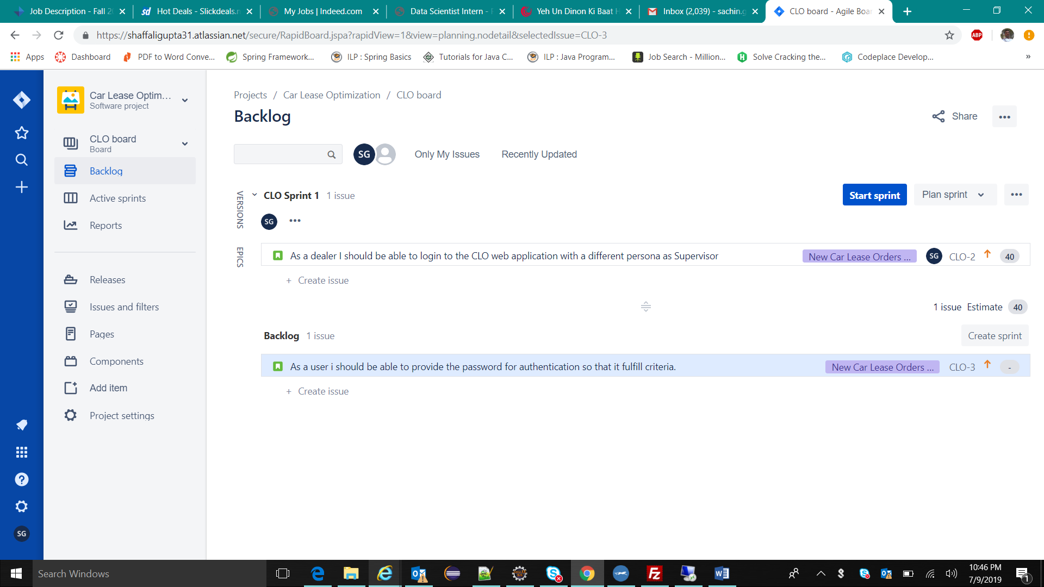

1. **Create Epic**

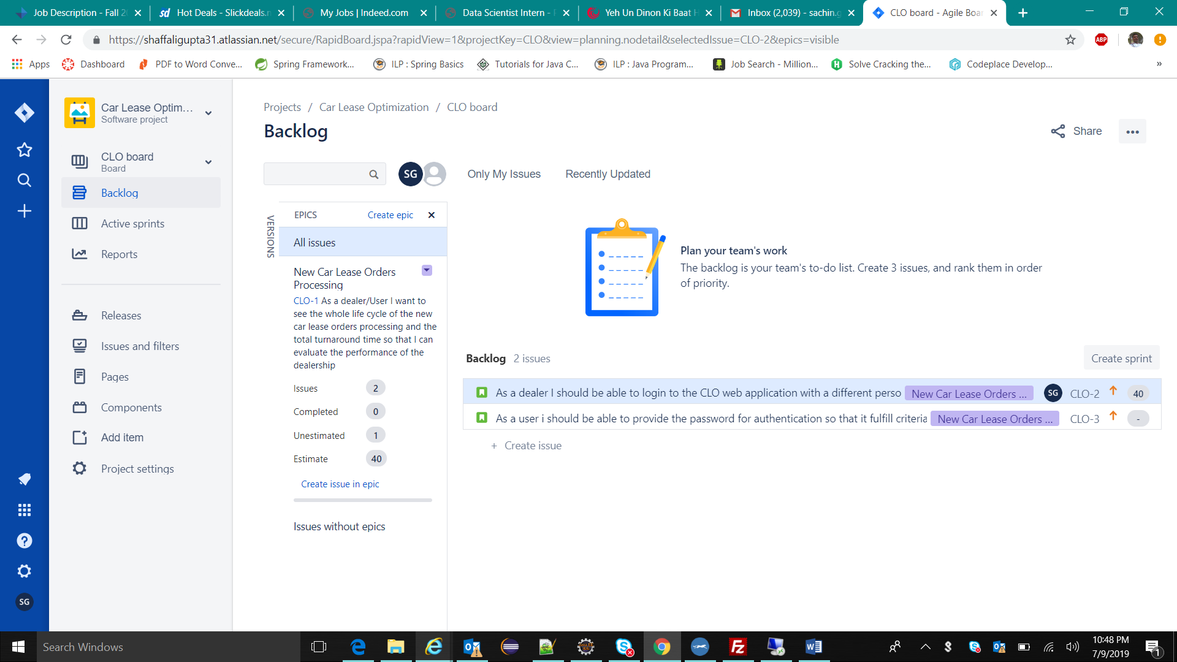

1. **Create user stories**

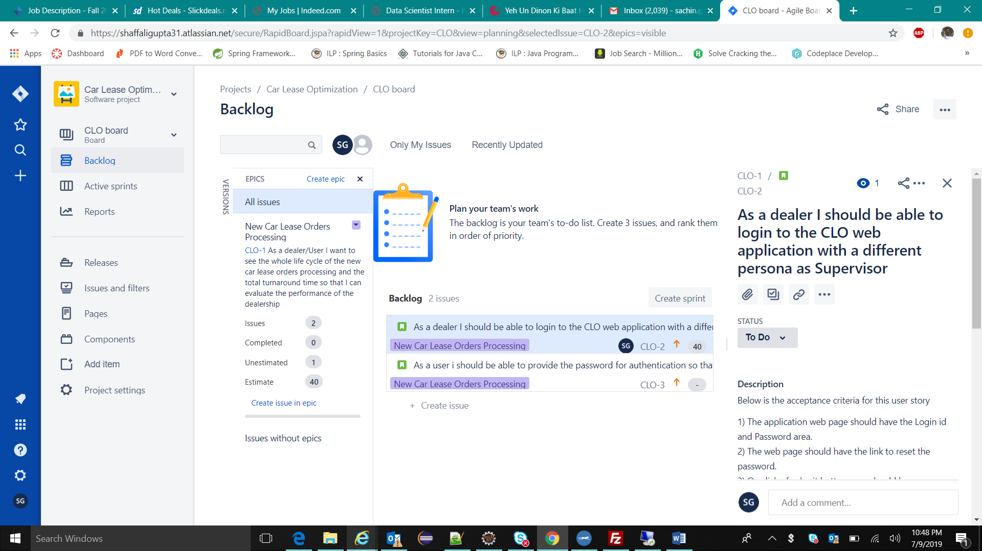

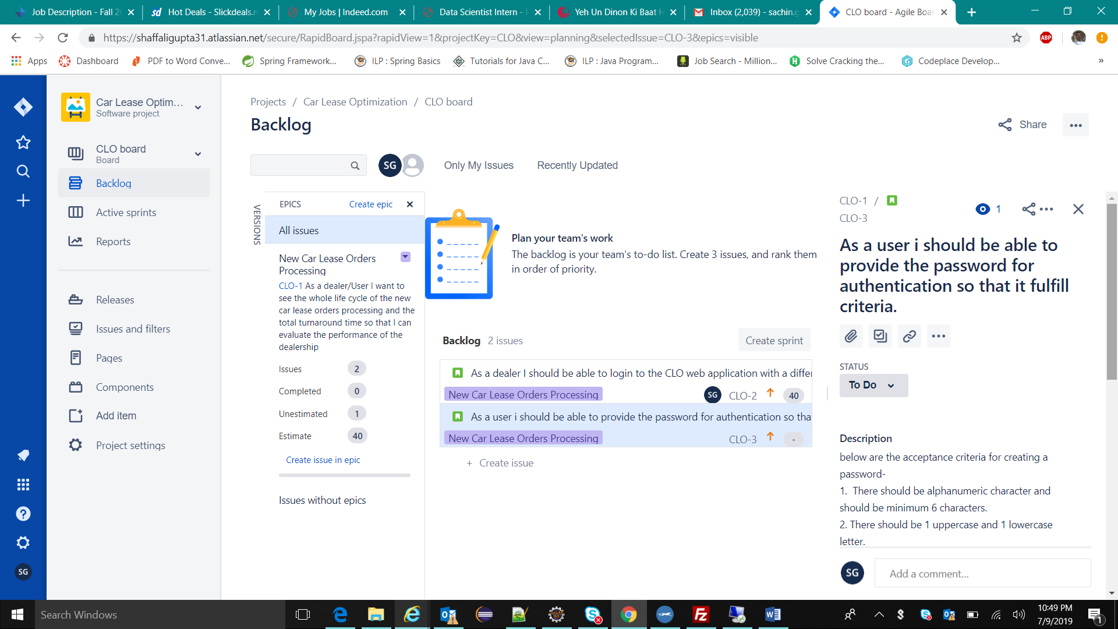

1. **Acceptance criteria**

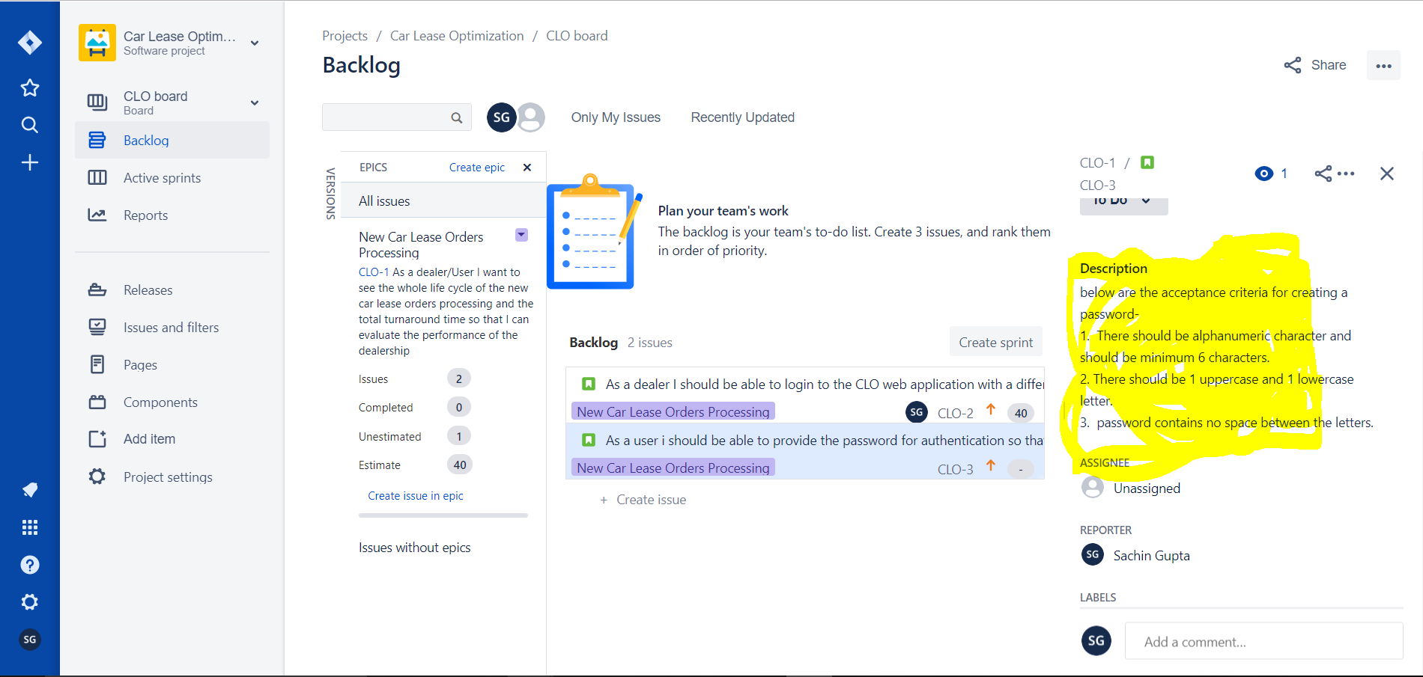

1. **DOD**

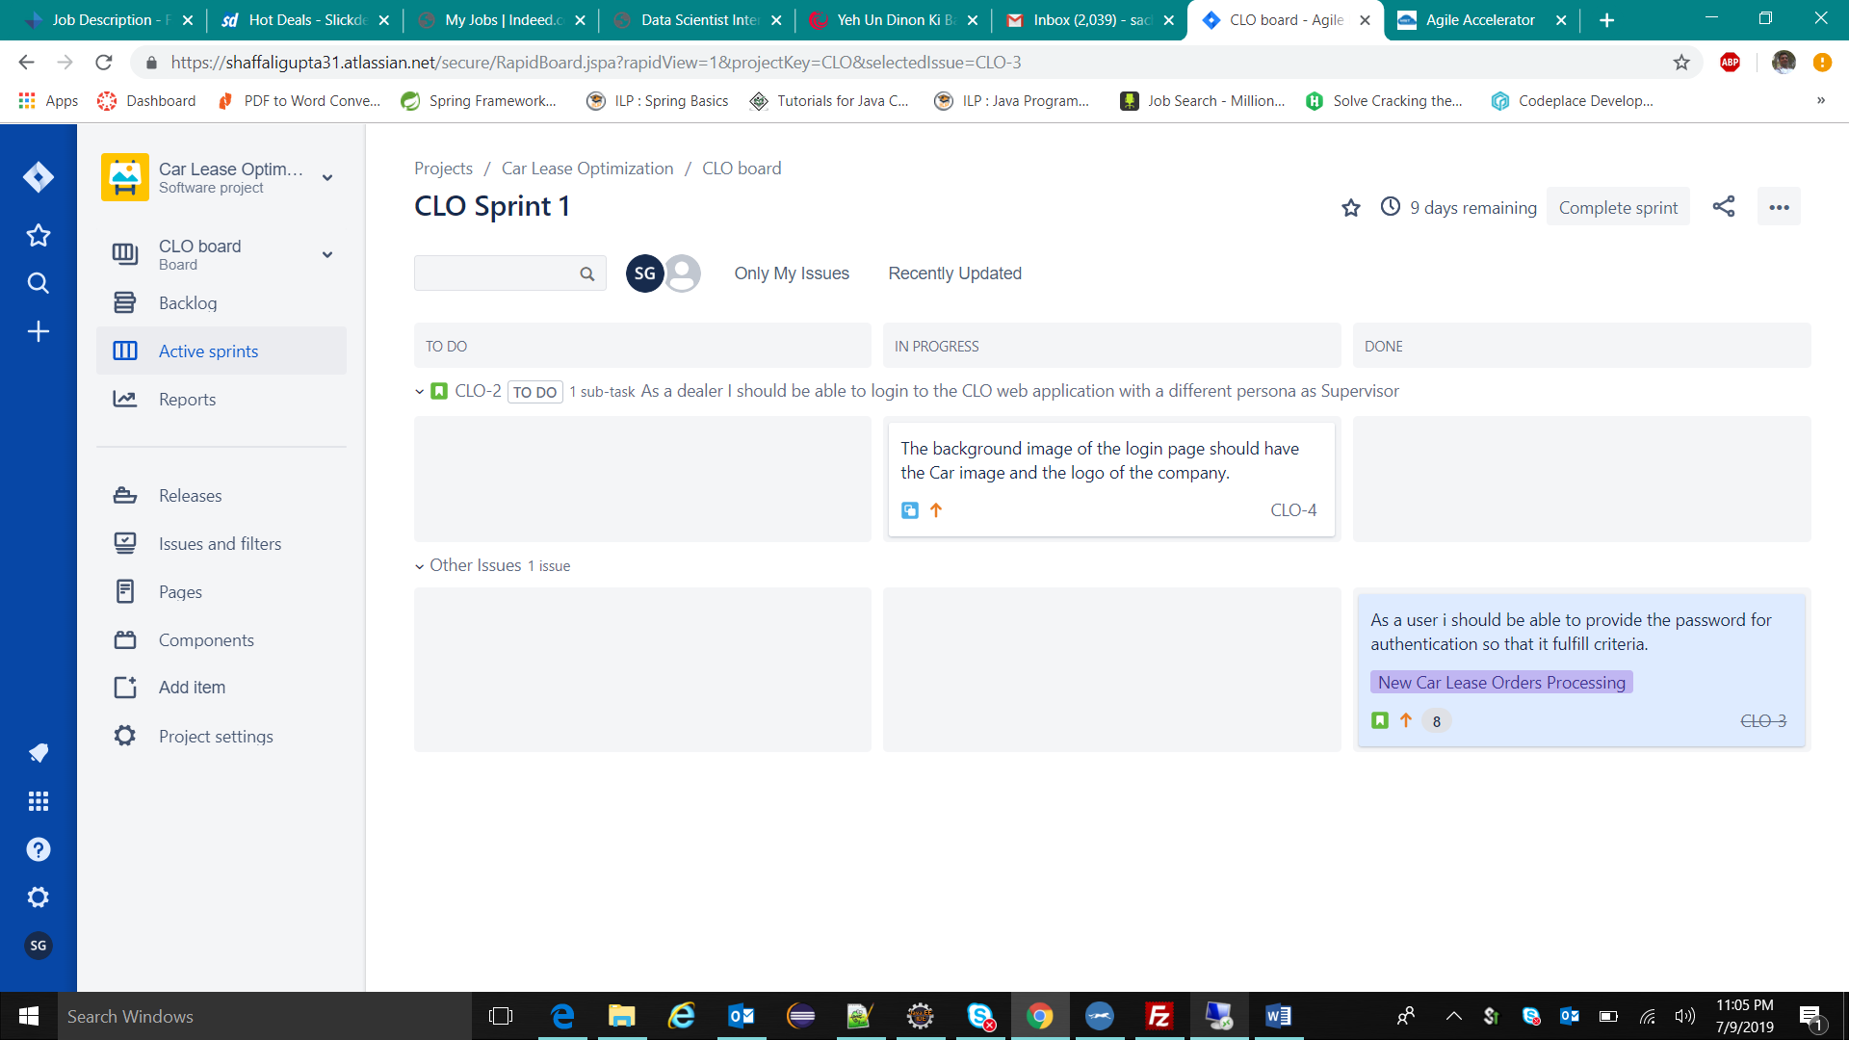

1. **Subtask**

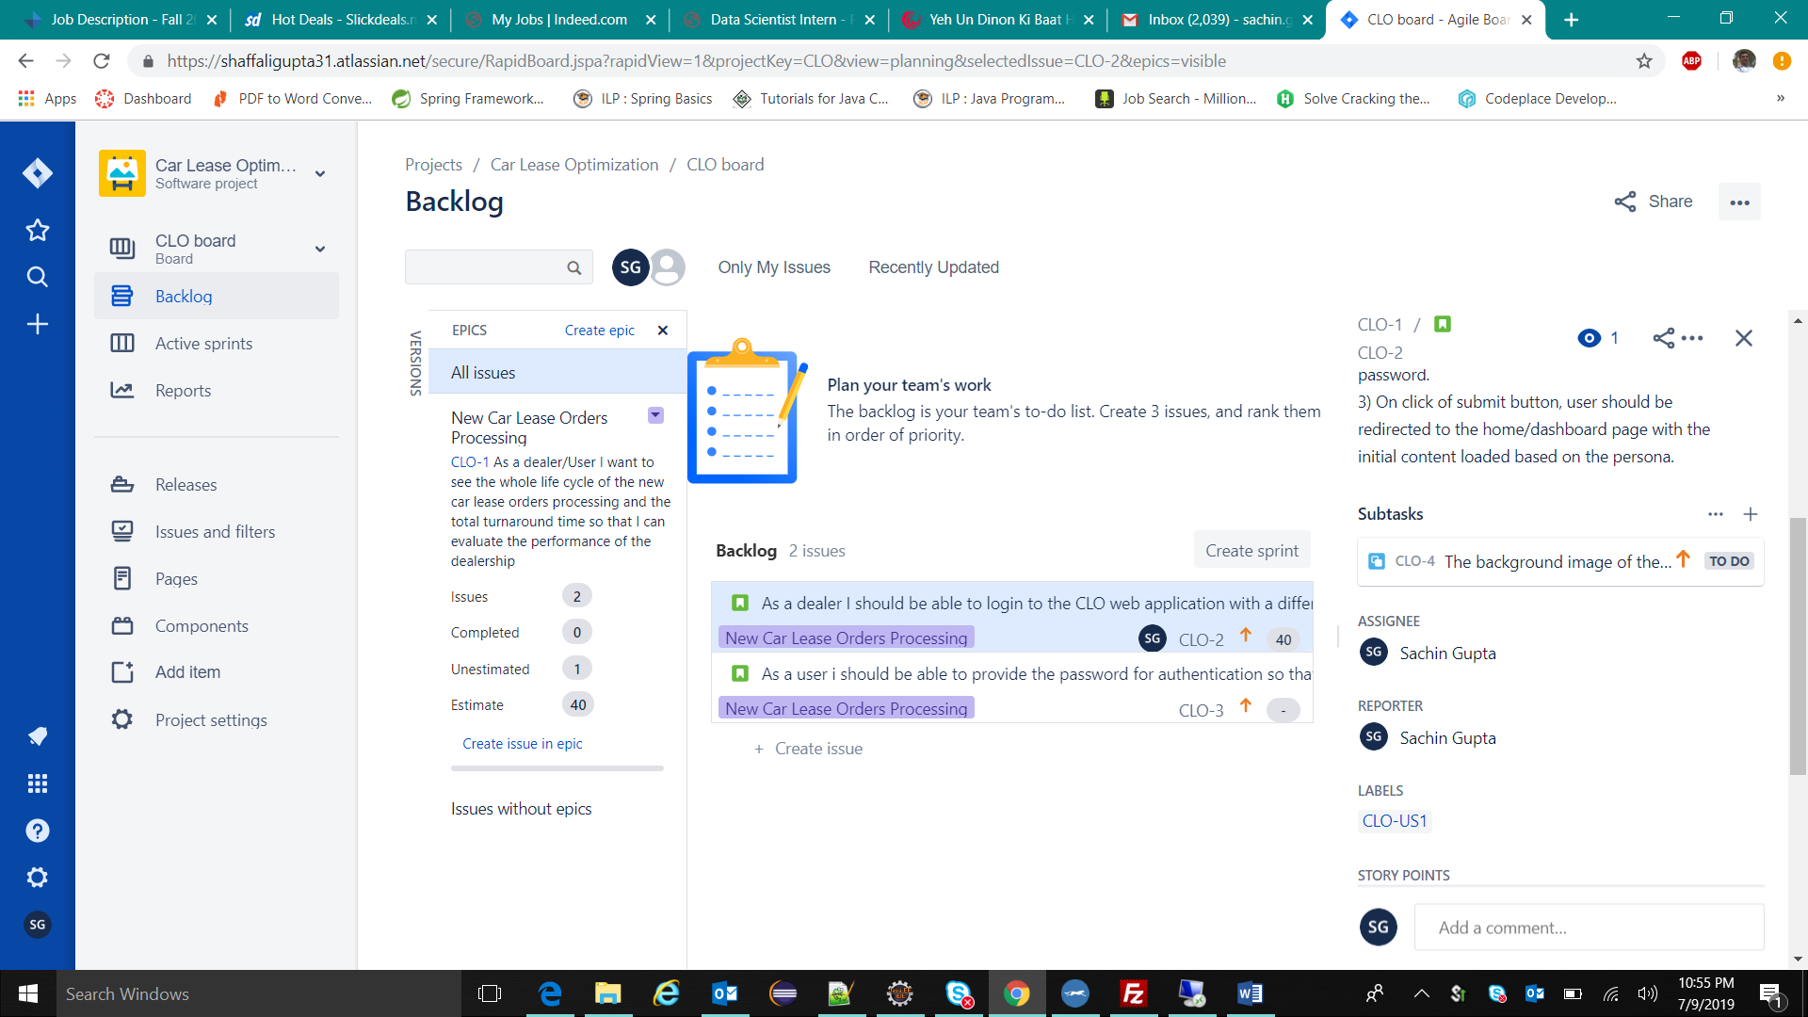

1. **Sprint plan and backlog item movement**

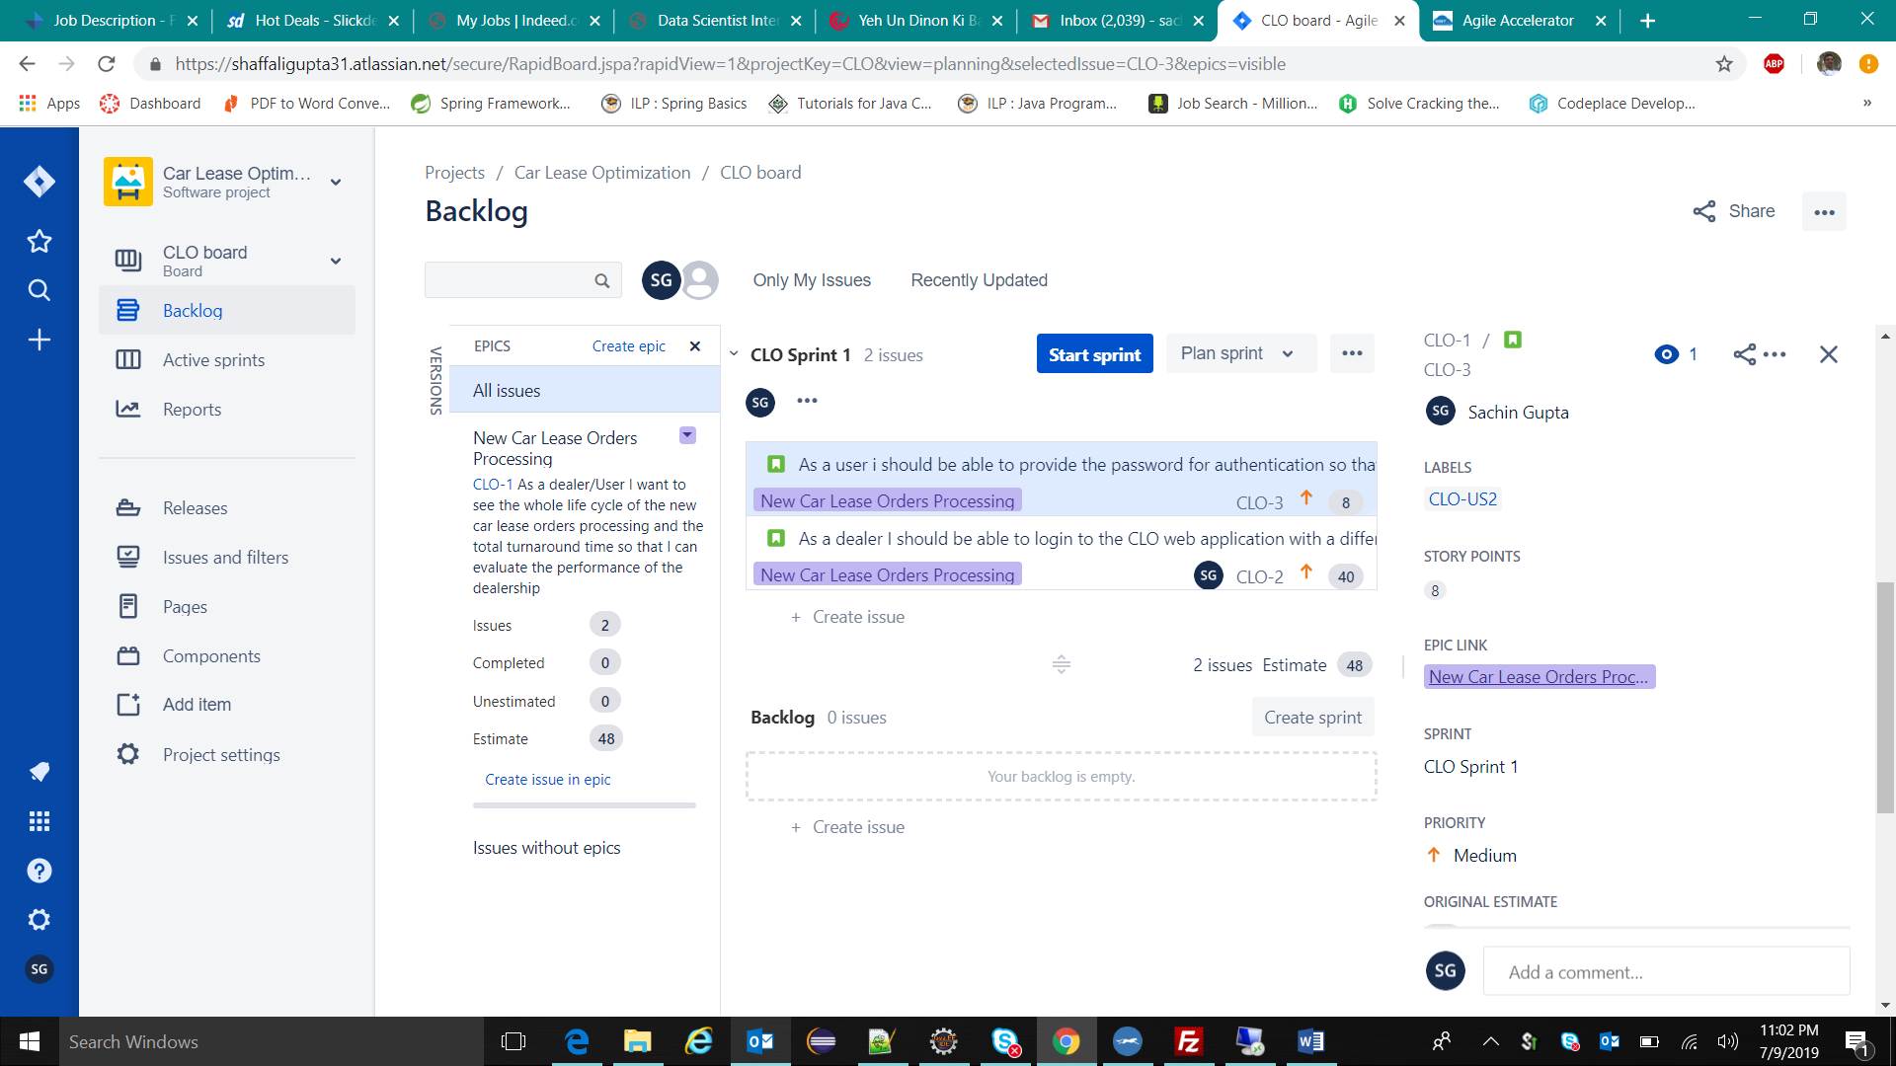

1. **Sprint Start**

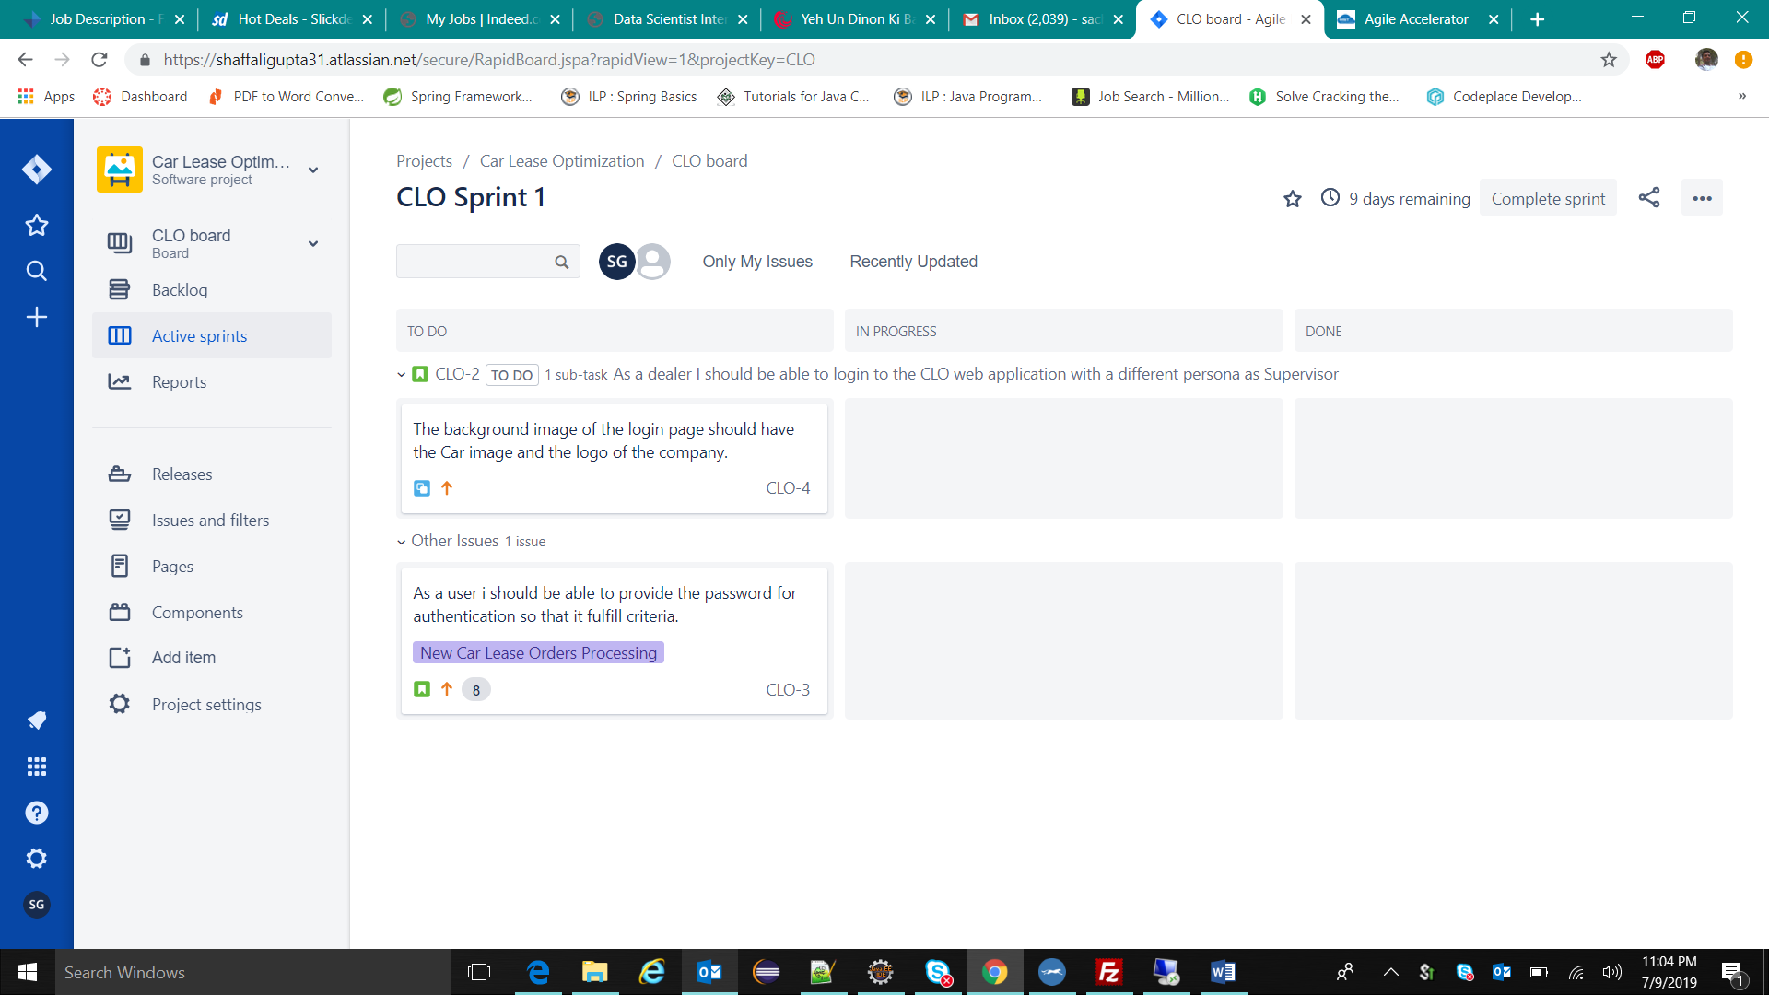

1. **Item progressing**

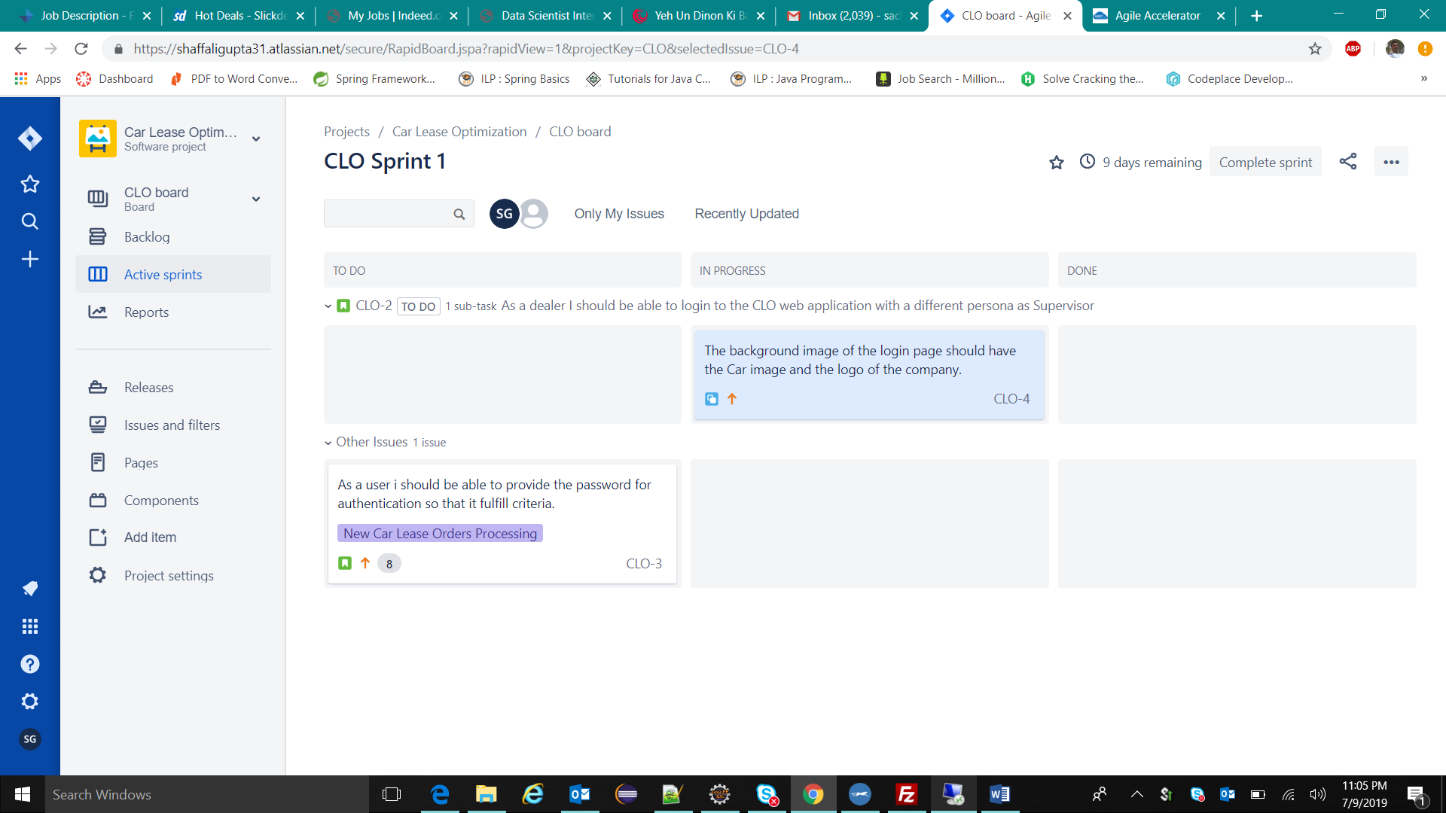

1. **Item Done**

